**Milestone 3**

**Zhuo Wen, Wilshire Liu, Yunwei Yan**

**Step 6:**

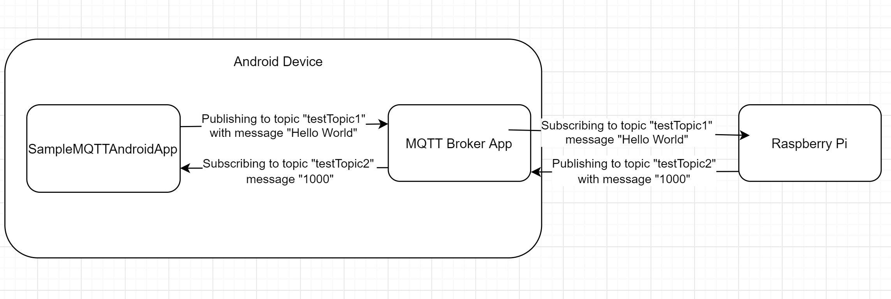

We have the MQTT broker running on the Android device using the MQTT Broker App right now. All of the data goes between the broker. In step 4, we were using the clients on the MQTT Broker App to publish and subscribe data, but in step 6, we are now using the SampleMQTTAndroid App to create the client. On the Raspberry Pi, we run the client.py script to start the publish/subscribe process. On the SampleMQTTAndroidAPP, once we press the button “Sync With Pi”, it will connect to the MQTT client on the Raspberry Pi. It will then subscribe to the topic “testTopic2” and receive the message “1000”. Then, the Android app publishes to the topic “testTopic1” with the message “Hello World”.

**Step 8:**

It is better to run the broker on the Raspberry Pi because the Raspberry Pi is more fault-tolerant and resilient to change. In case the Android device needs to switch Wi-Fi networks, we cannot have the broker on the Android device because this would change the IP address of the broker. Each time you switch back to the Raspberry Pi Wi-Fi network, the broker will need to be restarted. In addition, disconnecting the Android device from the Raspberry Pi Wi-Fi network would also cause any other clients that are publishing or subscribing to lose connection with the broker since it will no longer be on the network. Another reason could be that since the broker is now the Raspberry Pi, any data that is transferred to or from the Raspberry Pi will be be sent or received faster because now the broker is connected via hardware instead of wireless.

**Step 9:**

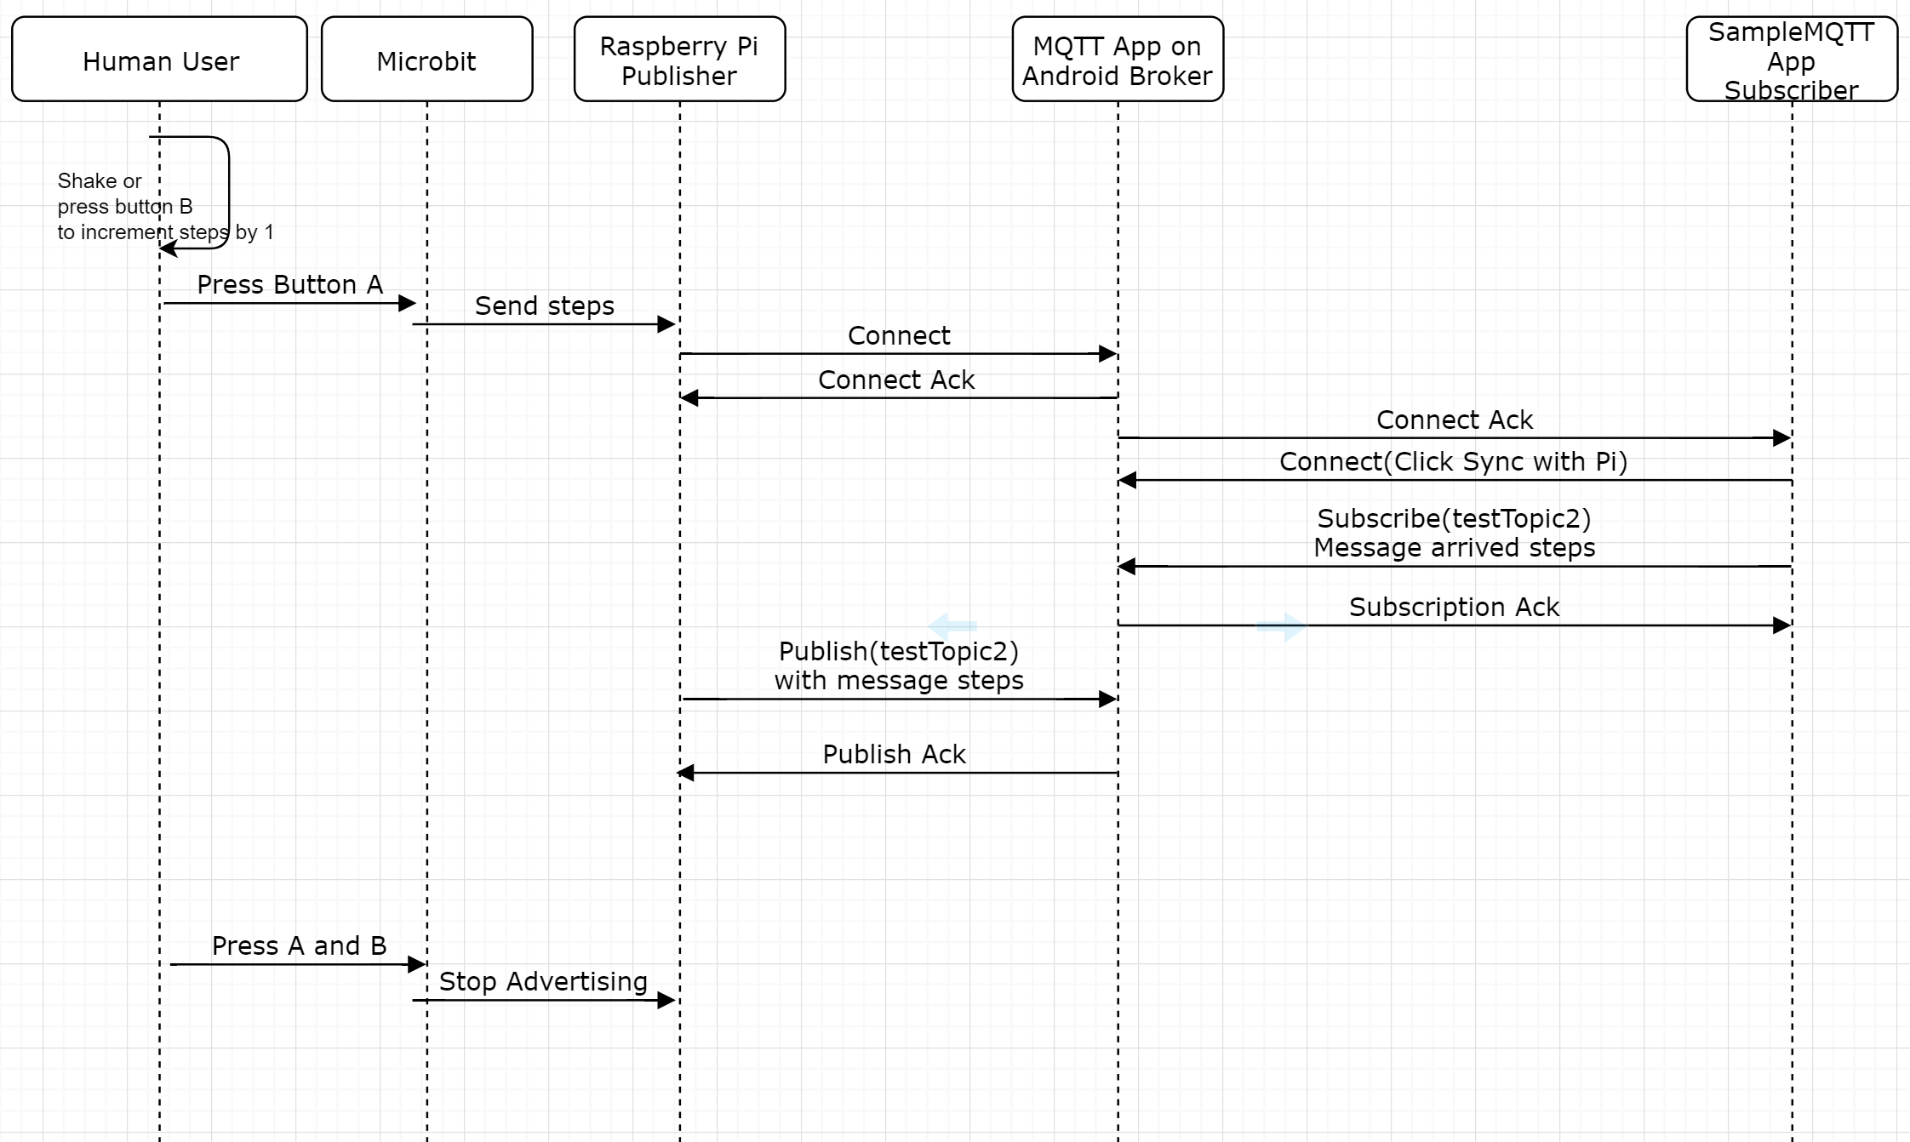

When you press button A on the microbit, it sends the number of steps that is stored in the microbit to the Raspberry Pi via EddyBeacon. Once the Raspberry Pi receives the beacon, it filters out the number of steps from the URL we provided, creates an MQTT client, and publishes the number of steps to the topic “testTopic2”. Then on the Android device, once you press the “Sync With Pi” button, it connects to the Raspberry Pi client and subscribes to the topic “testTopic2”. Once a new message arrives (the number of steps), it sets the text on the textView label to the steps that it received. When you press button b or shake the microbit, it increments the steps by 1, and when you press A+B, it stops broadcasting the steps to the Raspberry Pi.